You are provided with the following data for analysing the Cochin DC:
- sku_master: It contains information of BU, SKU, Brand, Model and Average Price
- sales_data: It contains information on Date, SKU, City and Volume
- opn_stk: Stock that is available as on 01-04-2021
- cochin_stk_trans: Contains information on incoming stocks to Cochin DC from 01-04-2021 – 15-04-2021.
Using the provided data, answer questions 1 to 9. Support your answers by pasting the necessary graphs and tables as pictures (when mentioned in the question). In addition to this document, submit the excel file, where you have performed the analysis.
- Create a Revenue Pareto Charts for Cochin DC. Show the Pareto table that has the top SKUs contributing to approximately 80% of the total revenue.
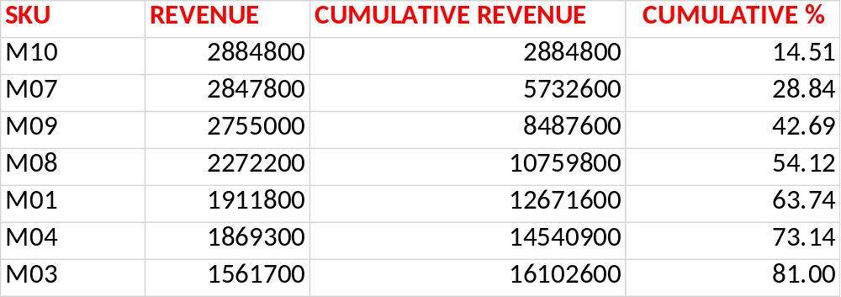
TABLE SHOWING TOP SKUs (approx. 80%)
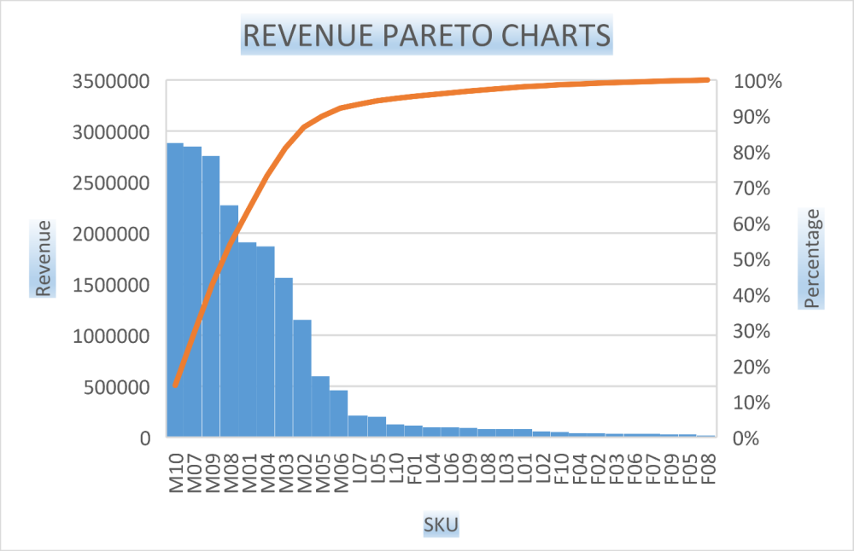
REVENUE PARETO CHARTS

.
- Create a single scatter plot for Cochin DC and show the scatter chart between volume and revenue. Identify 2 outliers, one in terms of revenue and the other in terms of volume (write down their values).

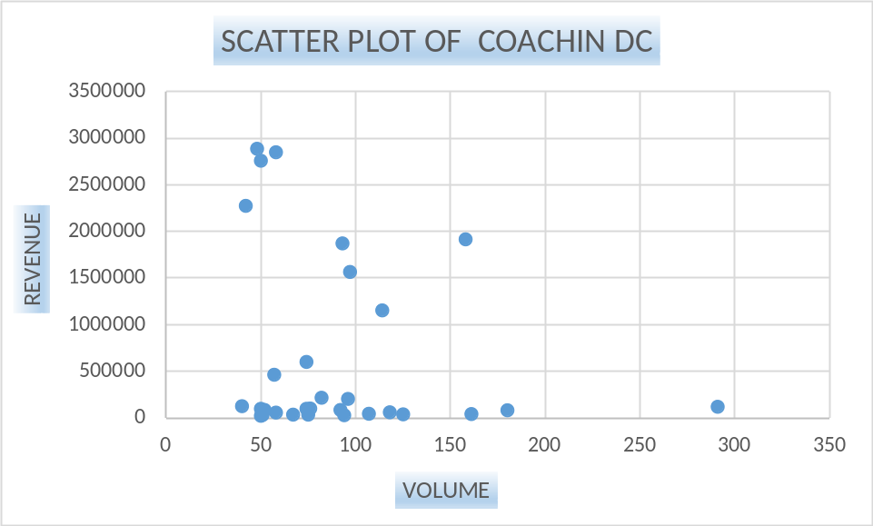

SCATTER PLOT BETWEEN VOLUME AND REVENUE

  - Revenue outlier: M10 (2884800 INR)
  - Volume outlier: F01 (291)

- Draw a line graph to identify trends with respect to volumes observed in the 15 days sale in Cochin DC? On 09-04-2021, how many units were sold?
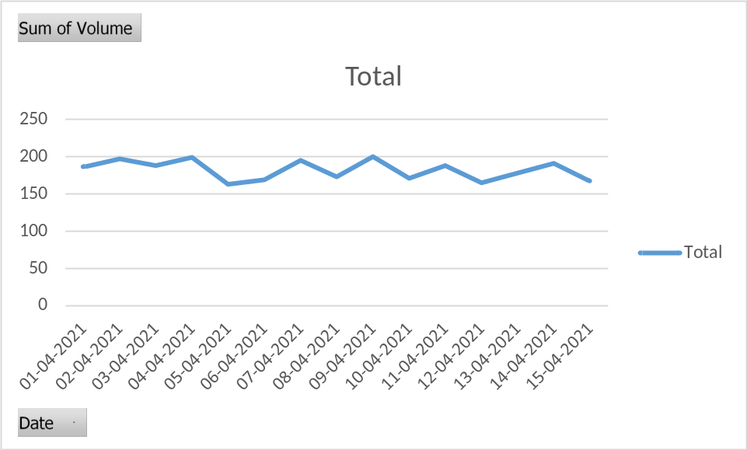
VOLUME TREND
Answer: 200 units
- Draw a line graph to identify trends with respect to revenue observed in the 15 days sale in Cochin DC? On 03-04-2021, how much revenue was generated?

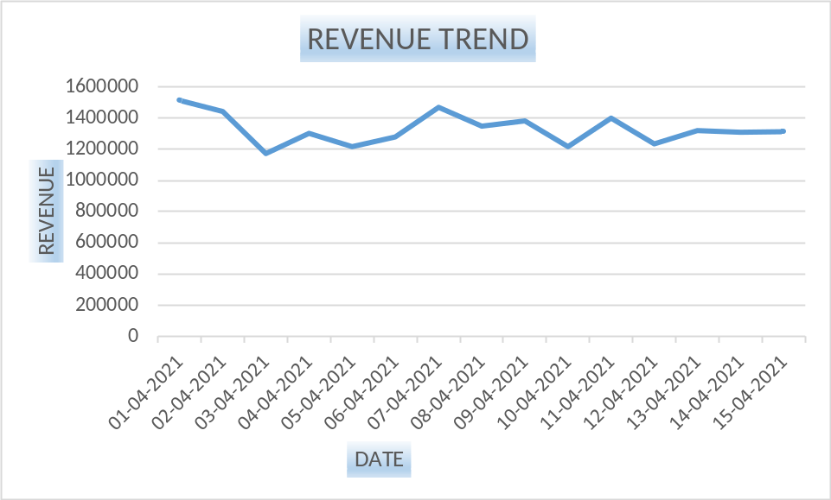

REVENUE TREND

Answer: 1172106 INR
- Draw a bar chart to represent the volume trend with respect to the days of the week in Cochin DC. Using the 15 days data, identify how many units were sold on Fridays?
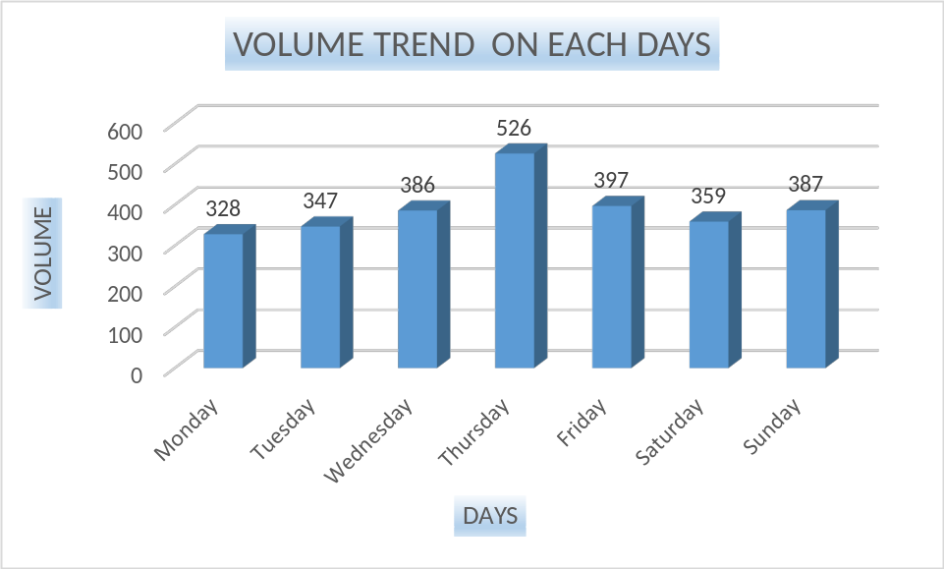

VOLUME TREND OF EACH DAYS

Answer: 397 units
- Draw a bar chart to represent the revenue trend in Cochin DC. Using the 15 days data, identify how much revenue was generated on Fridays?

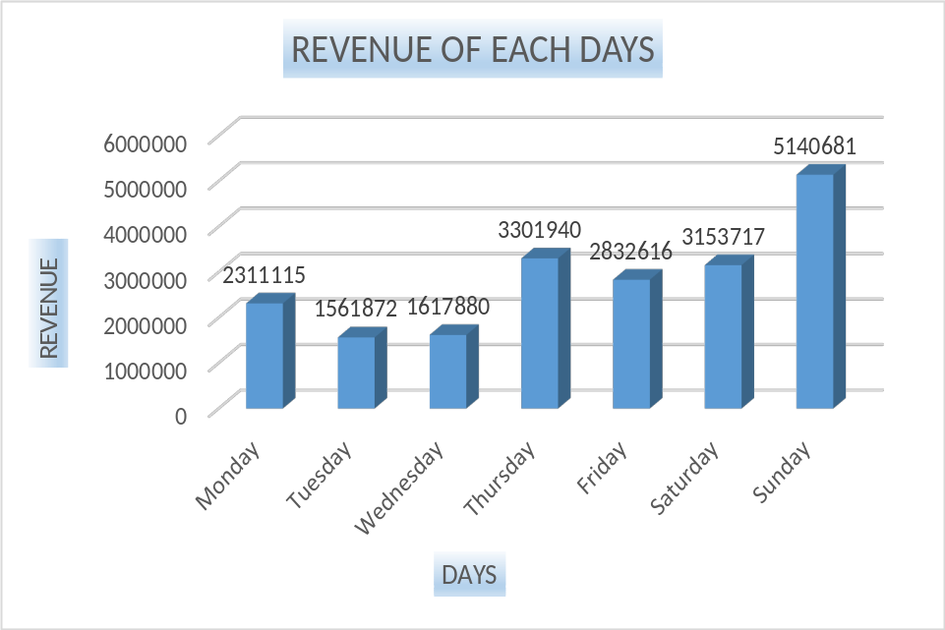

Answer: 2832616 INR
- Plot a graph to identify revenue trends with respect to the previous day. How much was the revenue growth on the 11th in comparison to the 10th?
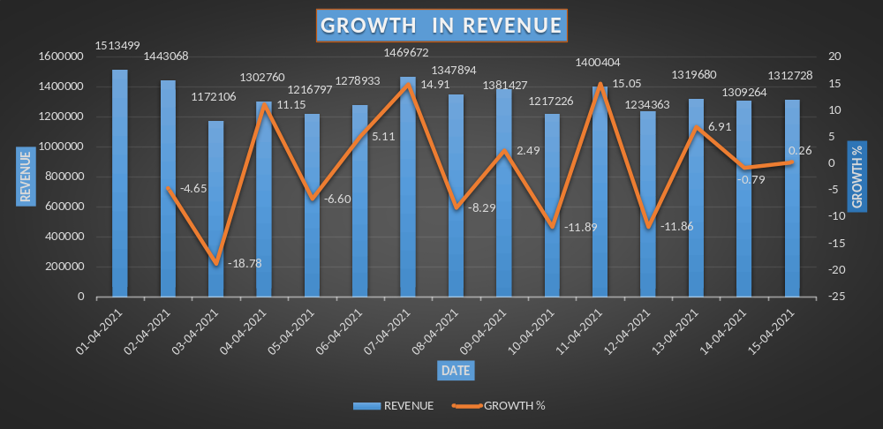

Answer: 15.05 %
- Create a ledger for the Cochin DC, and mention the closing stock of F01, M01, and L01 on 15.04.2021.

Answer: F01: 16; M01: -7; L01: 11;
- Calculate the average days of inventory for F04, M04, and L04.

Answer: F04: 1.0 ; M04: 0.3 ; L04: 0.7 ;

